
N-BOX- S5(AD600NA6L) (R100)
Features
- Onboard Intel Core 12th/13th generation -U/-P series processor, TDP15W;
- 2 x DDR5 SO-DIMM, total maximum 64GB;
- 6 x 2.5G network (LAN1-5 x Intel i226-V, LAN6 x RTL8156B);
- TPM2.0, 2*M.2 2280 SSD, E-Key (WIFI/BT);
- HDMI2.0+DP, 1*Type-C (USB+DP)
- DC 12-19V, 90W; Size: 134x126x41mm.
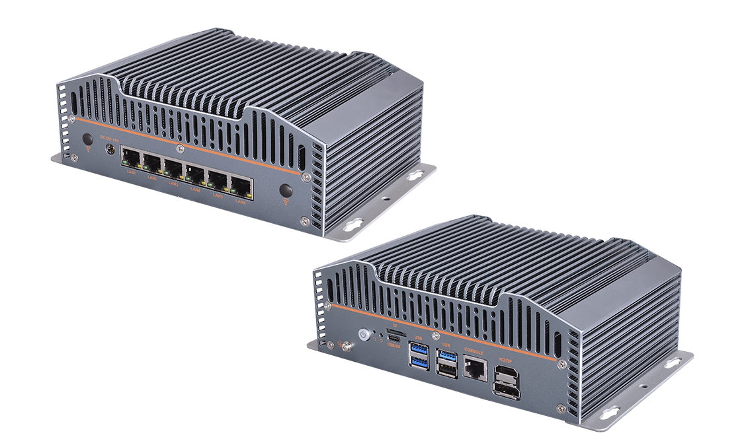

Product Specifications
Material | Aluminum profile, iron gray
Processor | Onboard Intel Core 12th / 13th generation -U/-P series processor, TDP15W
Processor | EFI BIOS
Memory | 2 x DDR5 SO-DIMM, total maximum 64 GB
Storage | 1 x M.2 M-Key 2280 (PCIe 4.0 x 4)
Storage | 1 x M.2 M-Key 2280 (next to E-Key, PCIe 4.0 x 4/SATA3.0 protocol optional) Please note when placing an order
Storage | 1 x 2.5-inch SATA3.0, 2Pin 5V power supply
Display | 1 x HDMI2.0, 4K@60Hz
Display | 1 x DP, 8K@60Hz
Display | Type-C interface (DP 8K@60Hz + USB3.2)
Board Edge I/O interface | DC JACK, 6 x LAN, 1 x HDMI, 1 x DP
Board Edge I/O interface | 4 x USB, TF card, Type-C (USB+DP)
Board Edge I/O interface | Switch button, reset button, 1 x CONSOLE
Extended interface/function | External TPM2.0 optional
Extended interface/function | 1 x E-Key (PCIe+USB2.0, WIFI/BT)
Power Supply | DC 12-19V, 90W
Working Environment | Working temperature: -20℃ ~ +60℃; Working humidity: 5% ~ 90%
Working Environment | Storage temperature: -40℃ ~ +85℃; Storage humidity: 5% ~ 90%
Operating System | Windows10, Windows11, Linux
Size | 216 x 123.6 x 67.5mm​​​
Weight | Host net weight is about 1600g, the gross weight is about 2500g.
N-BOX-S5(AD600NA6L) (R100)

Product Size Unit: mm

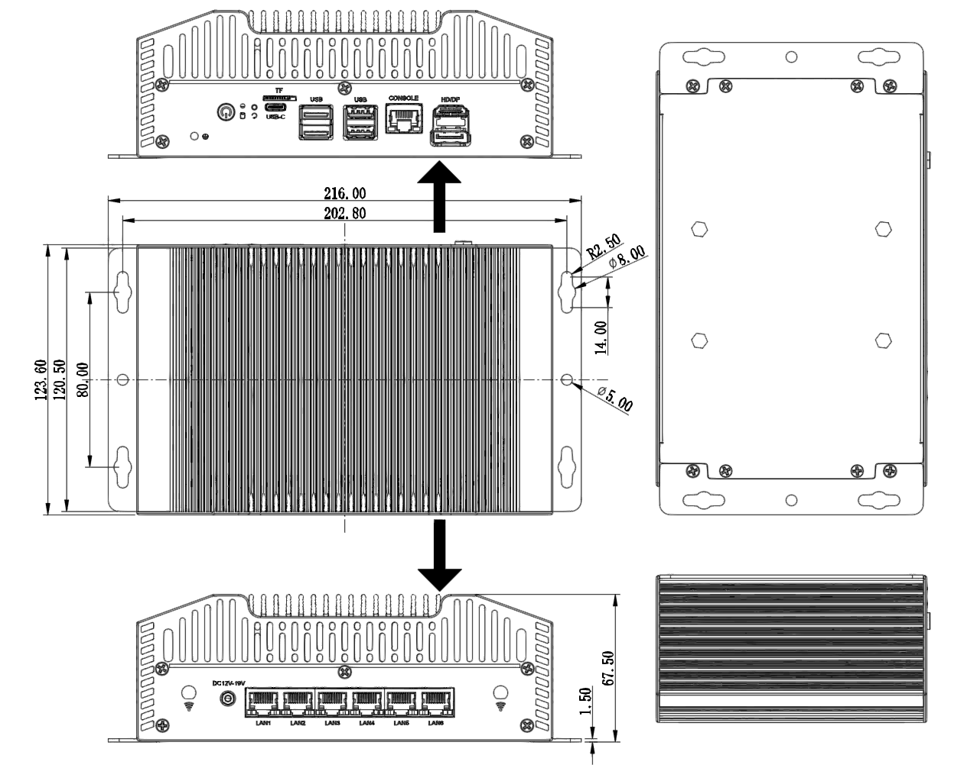

Ordering Information
Model | Optional items | Description of options
N-BOX-S5 | Onboard Intel Core 12th / 13th generation -U/-P series processor | 1215U  1235U  1255U  1220P  1240P  1260P
N-BOX-S5 | M.2 2280 protocol next to E-Key | PCIe/SATA protocol optional
N-BOX-S5 | 2.5-inch SATA | optional, with bracket by default
N-BOX-S5 | TPM2.0 | External TPM2.0 optional

